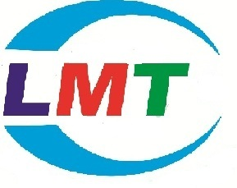

**ABOUT COMPANY**

**1.1 Company Profile**

With the active participation of its multi-disciplinary Assignment Execution Team, LMT (Logic Mind Technology) Software Solutions Pvt Ltd. has emerged as a leader in the ITES in India and has established itself in the field of software development, data processing, data conversion, digital printing, Digitization, System integration, smart card personalization, IT facility management and other IT enabled services. LMT Software Solutions Pvt Ltd., incorporated in 2011, is a professionally managed, rapidly growing, multifaceted Information technology company. The company is actively involved in developing automation and e-Governance solutions for Transport, Social Security, Citizen Identity, Education, Public Distribution System, Retail Management and a host of other application areas.

LMT Software Solutions Pvt Ltd. is a leading System integrator in India providing complete turnkey solutions on BOO & BOOT basis including facility management services, Smart Cards applications, Document Management System (DMS), Work Flow Management and Manpower Deployment.

LMT Software Solutions Pvt Ltd. has successfully completed many e-governance projects for the various departments of Govt of AP and has won accolades for its superior service delivery, timely execution of projects and the quality of the deliverables. LMT is being trusted by many clients who are looking for reliable and quality services for their business. LMT is currently operating and managing in Bangalore and giving services to e-commerce business services.

LMT Software Solutions Pvt Ltd. adopted project team and dedicated organization structure. In project based organization, the project manager’s directors have a high level of power to oversee and control the project assets. The project manager in this structure has downright power over the project and can secure assets expected to fulfil project targets from inside then again outside the parent organization, subject just to the extension, quality, furthermore, budget constraints are identified in the project.

In the project based structure, staff is particularly relegated to the project and report specifically to the project manager. The project manager is in charge of the execution evaluation and vocation movement of all undertaking colleagues while on the project. This prompts expanded project faithfulness. Complete line power over undertaking endeavours bears the project manager solid undertaking controls and brought together lines of correspondence. This prompts quick response time and enhanced responsiveness. In addition, project work forces are held on a restrictive instead of shared or low maintenance premise. Project teams create an in number feeling of task recognizable proof and possession, with profound faithfulness efforts to the project and a decent comprehension of the way of project's exercises, mission, or objectives.

**1.2 VISION**

Vision Statement:

“To be the pioneer in e-commerce solutions by building and implementing robust and future proof systems which are efficient, transparent and accountable.”

**1.2.1 Our Values:**

The core values which lay the foundation for LMT Software Solutions Pvt Ltd. Are:

* Honesty & Integrity
* Respect & Dignity
* Terms Spirit & Camaraderie
* Openness & Transparency
* Empowerment

### **1.2.2 Our Goals:**

Our company objectives as follows:

* To promote a profitable and sustainable business activity that meets the customer’s needs.
* To increase the company's market share
* To gain the competitive edge
* To increase the company's role in relations to social responsibility
* To provide excellent customer service

**1.3 Organization Structure**





Fig 1.8.1 Organization Structure

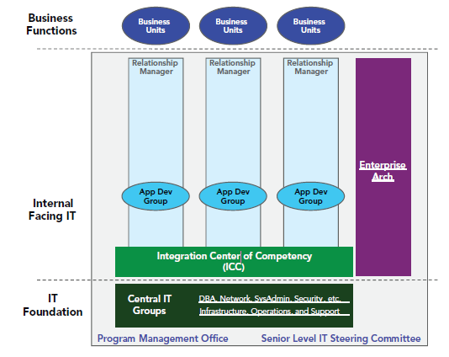

Fig 2.2 IT organization layers

**LMT Software Solutions Pvt Ltd. - Software Services**

* Software Development
  + Software Application Development
  + Customized Software Development
  + Offshore Software Development
  + SOA and SaaS
* Web Application Development
  + ASP.NET Web development
  + Web Application Maintenance Services
  + .Net Technologies like C#, ASP.NET, VB.NET
  + Share Point Services/MOSS
  + Flex, Silverlight and Ajax
* Website Designing and Graphic Designing
  + Application Integration Services
  + Web and Graphic Designing
* Mobile Application Development
  + Windows Phone Apps Development
  + Windows Phone Game Applications

**1.4 Modern tool usage**

The software team at Logic Mind Technologies has extensively worked on various flavours of UNIX and Windows based environment. Few of the UNIX operating systems, which have been used by the organisation, are Sun Solaris, Tru64 UNIX & Linux.

The team at LMT has developed large scale and complex applications on Oracle, SQL Server and DB2. There is also substantial working expertise on MySQL and MS Access.

The web server experience extends to the following:

* Apache on Unix and NT Servers
* IIS on NT Platforms
* J2EE Compliant web servers (JSP version 1.10 & Java Servlet version 2.2)
* Netscape Server
* Oracle Web Server

Operating Systems : OS/400, UNIX, Windows 8, Windows 3.11/8.1/10

Database Environment : DB2, Oracle, SQL Server, MS Access, MySQL, CICS

Languages : NS2, Java, EJB, XML, RMI, WAP, C/C++, CL/400, RPG

Web Enabled Systems : MS-IIS, Visual Interdev, Websphere, Weblogic

Front End Tools : Visual Basic, Visual C++, Power Builder, VisualAge,

Jbuilder, Developer 2000

Web Designing Tool : FrontPage 2000, Flash

Data and Object Modelling : Rational Rose

Our Team members have extensive knowledge in Oracle Products ranging from Oracle 7.3 to 10i, Developer 6i, Oracle 10iAS and other oracle products.

**1.5 Successful Build**

For successful building of any project we need the following:

1. Business requirements

2. Smart Planning

3. Open Communication hub

4. Calculate Risk Management

5. Strong Project Solutions

6. Proper design development

7. Strong implementation

8. Efficient testing

9. Successful delivery

10. Support maintenance

**1.6 Contact Information**

Company Name : LMT Software Solutions Pvt Ltd.

Development &

Data Processing Centre : #17/46, 1st Floor, Service Road

Remco Layout, Bangalore-40.

General Phone No : 080-41155670

Company Email : [info@lmtsoftware.com](mailto:info@lmtsoftware.com)

Website : [www.lmtsoftware.com](http://www.lmtsoftware.com)

Contact Number : 9036159759